**ASSIGNMENT 1 ESWAR VARDHAN**

**A0000076347**

**PART 1: Launching an instance**

**1.**Opened the AWS EC2 and changed the region to **N Virginia.**

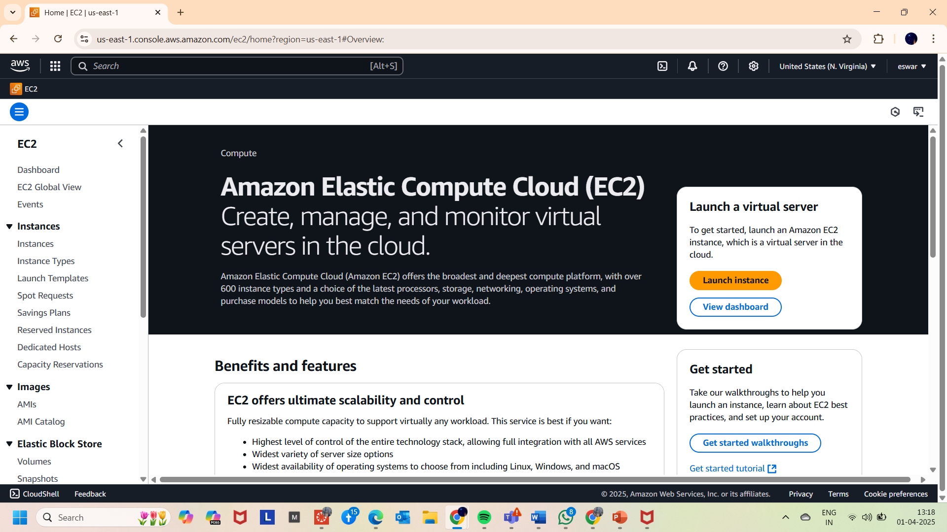

2.Updated the new tag with value **“httpserver1” shown below**

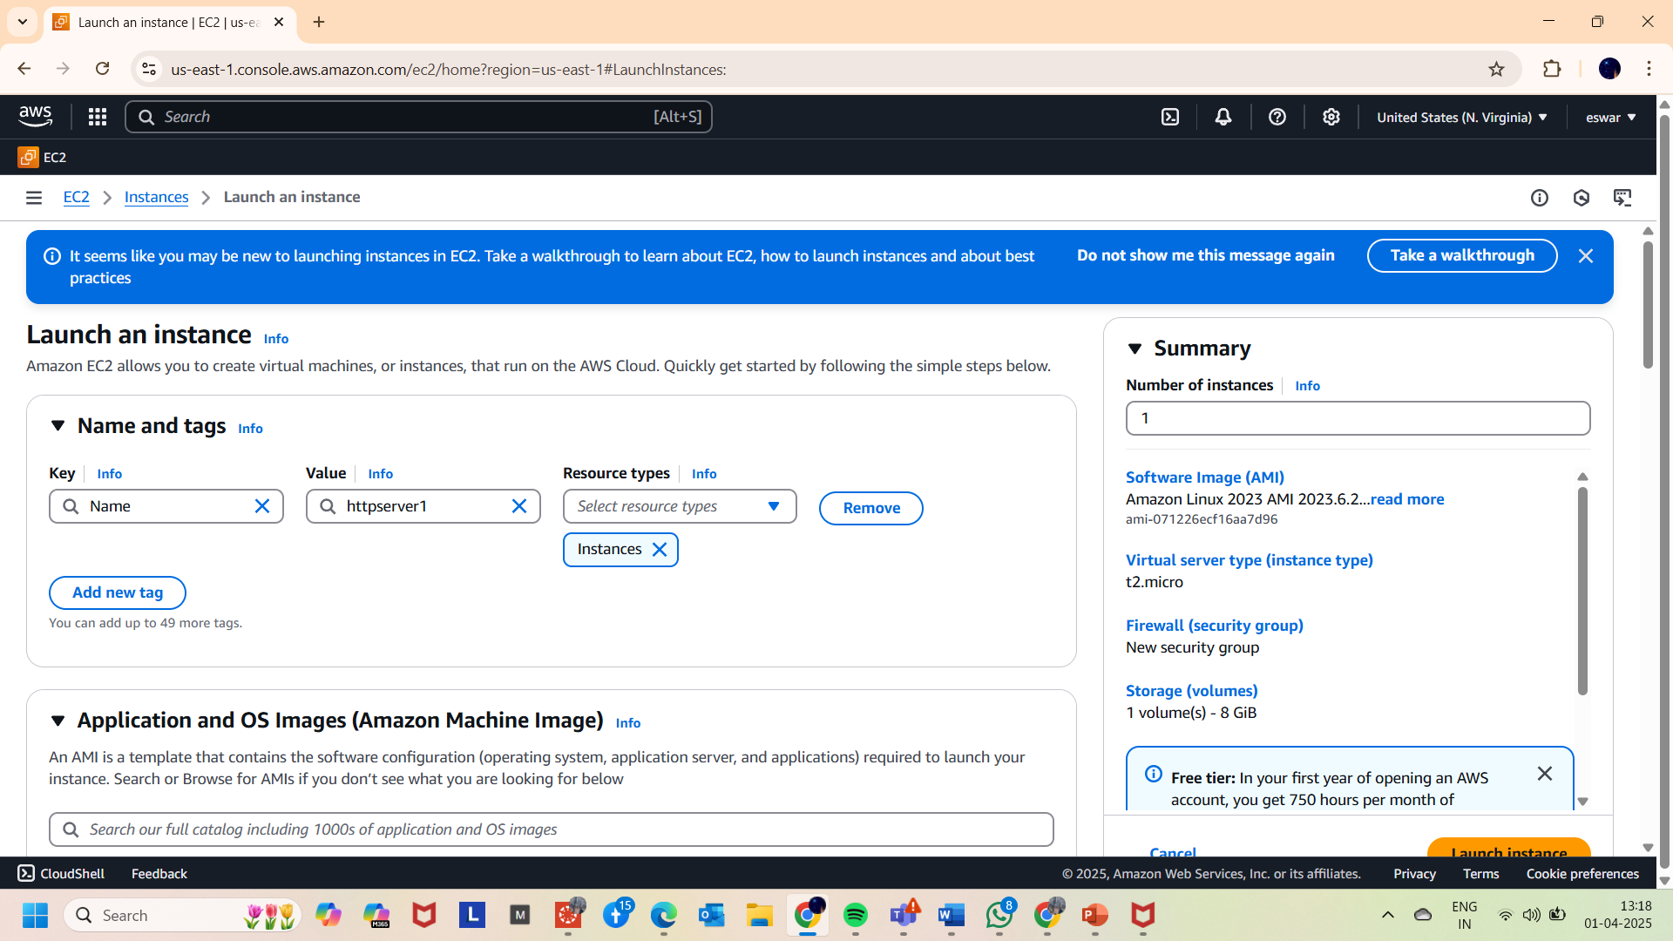

3. Chosen the **AMAZON LINUX AMI** image as OS

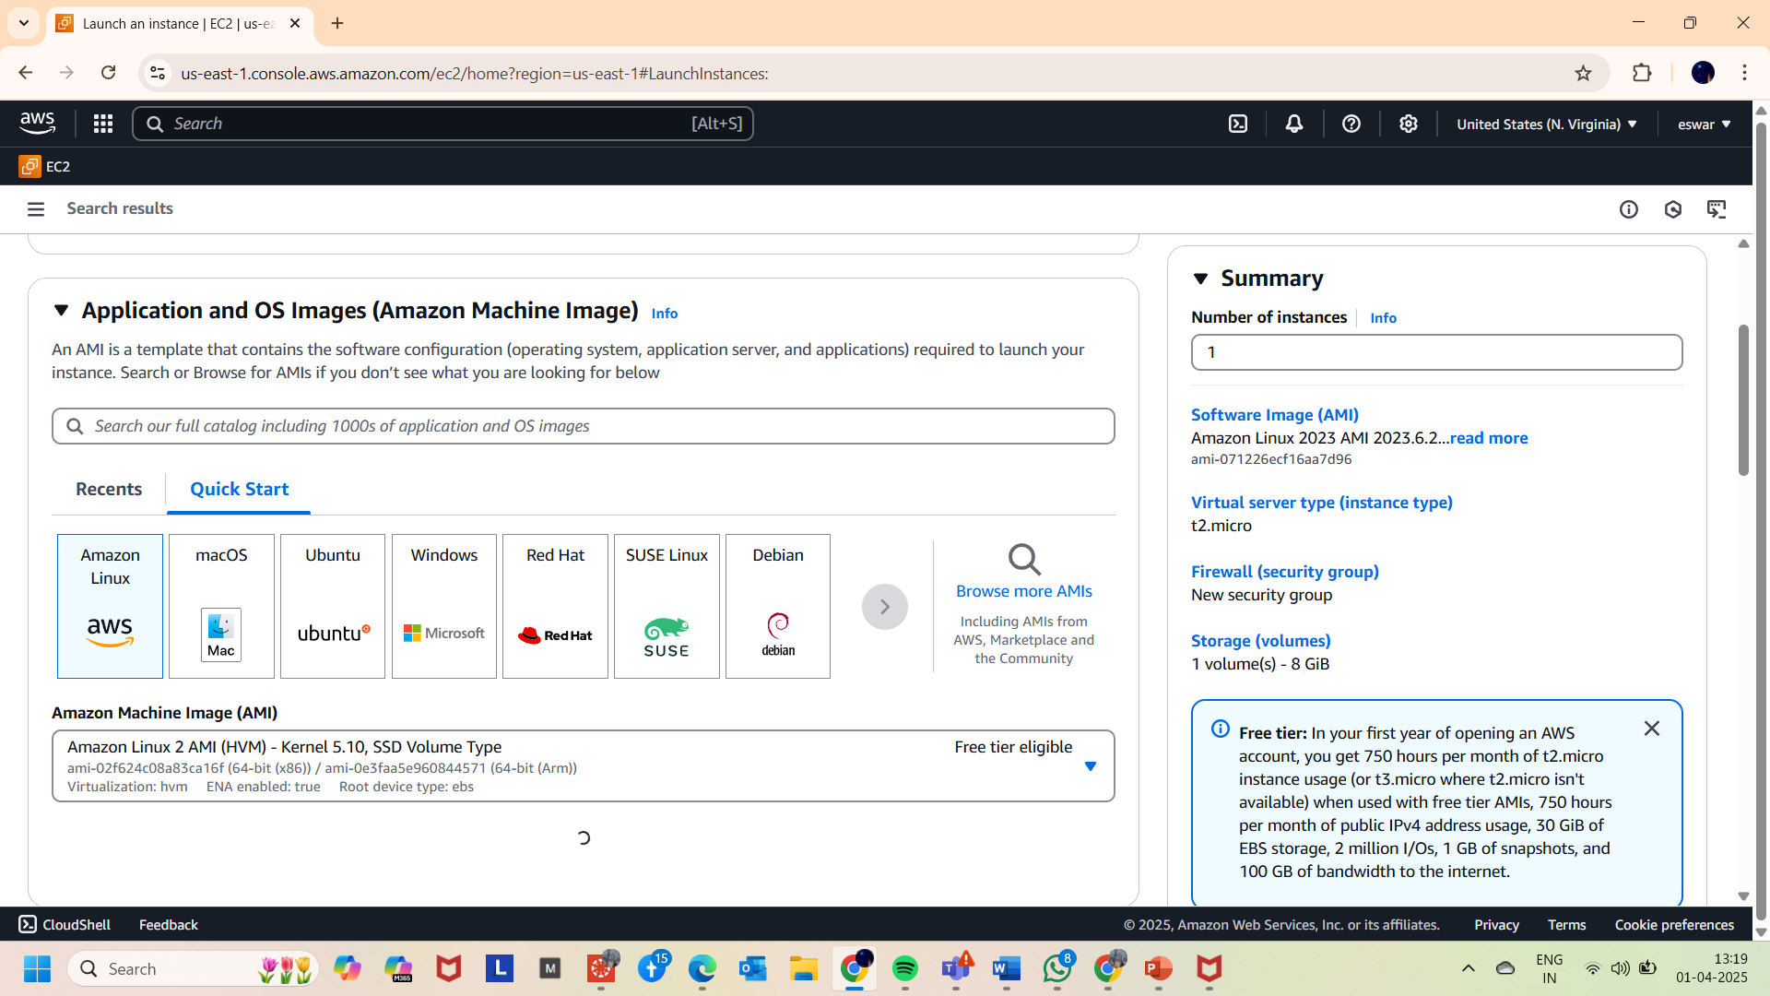

4.Ensuring the instance type is **t2.micro**

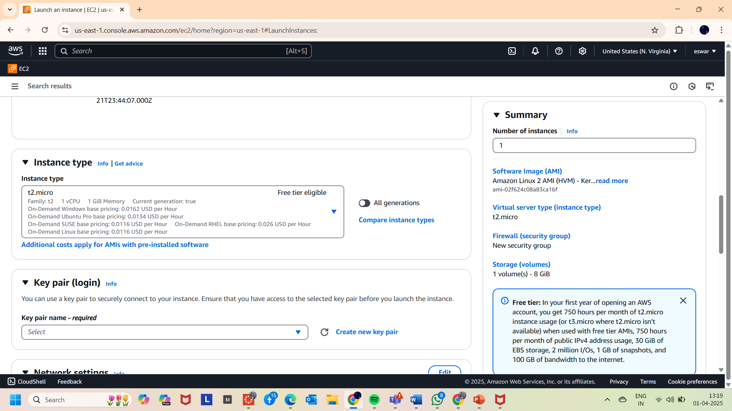

5.Downloaded the key pair for login (**KEY.pem**)

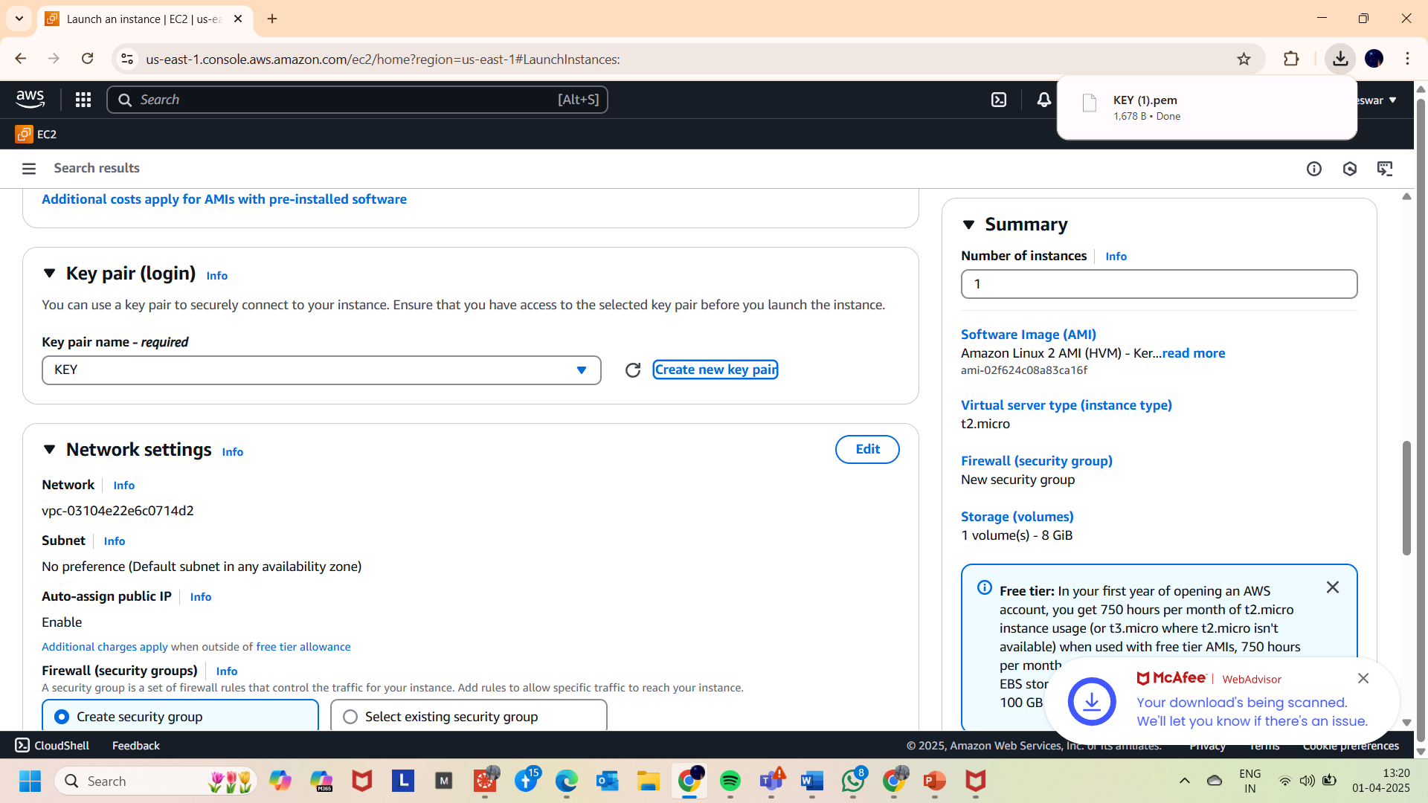

6.In the network settings..

* + Updated the subnet to east us 1a.
  + Enabled auto assign public ip.
  + And added a security group “assign 1-sg”.
  + Given description “opens security groups for ssh and http”.

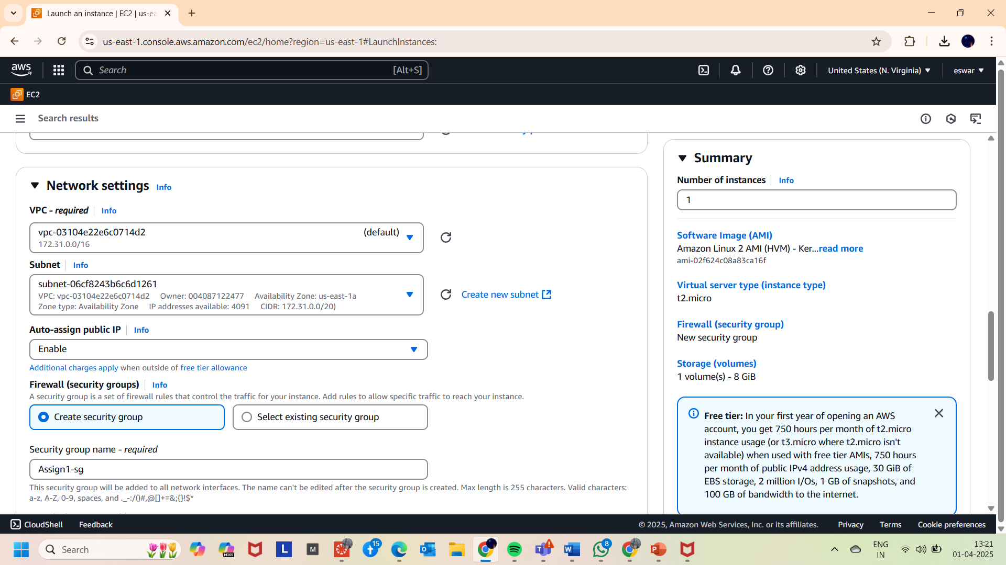

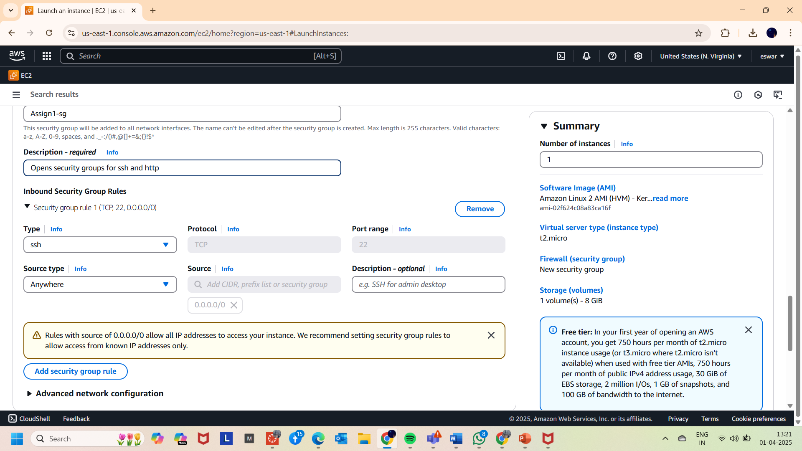

7. Added security group rule for “**http”** and given “**Anywhere**” as source type

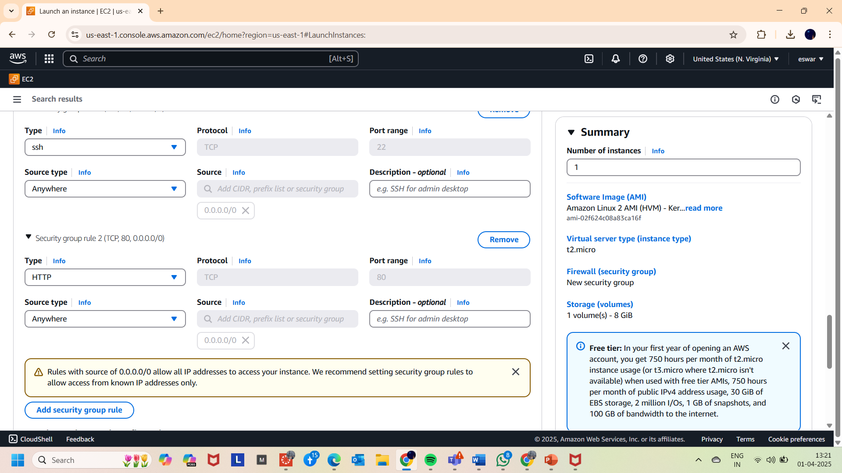

8. Uploaded the bash script as seen below in the

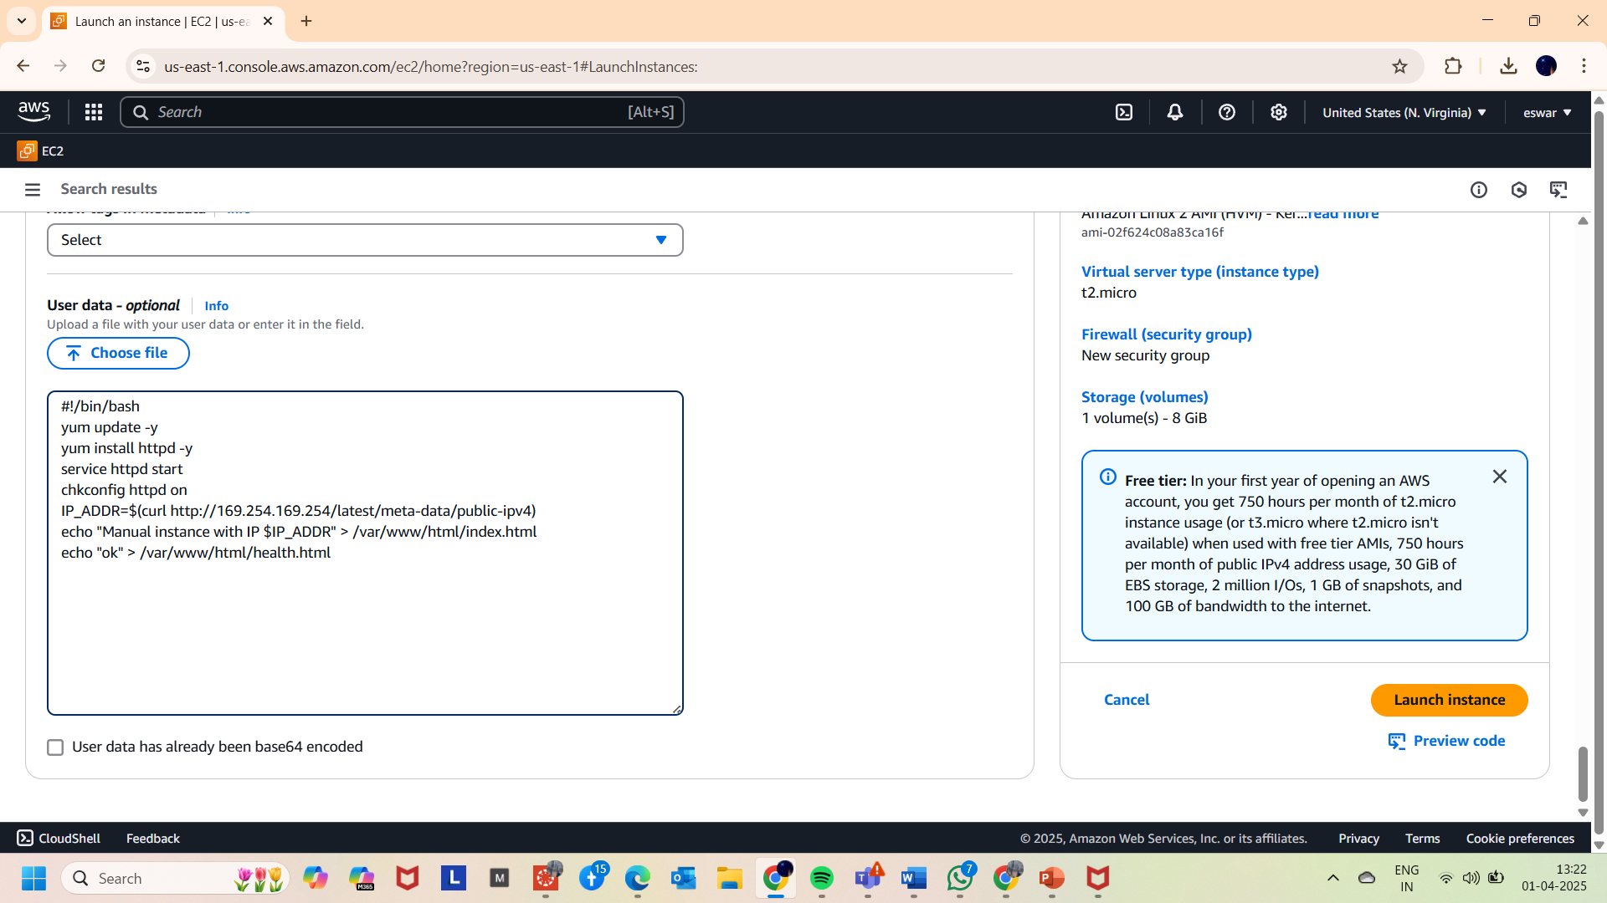

9. And launched the instance successfully.

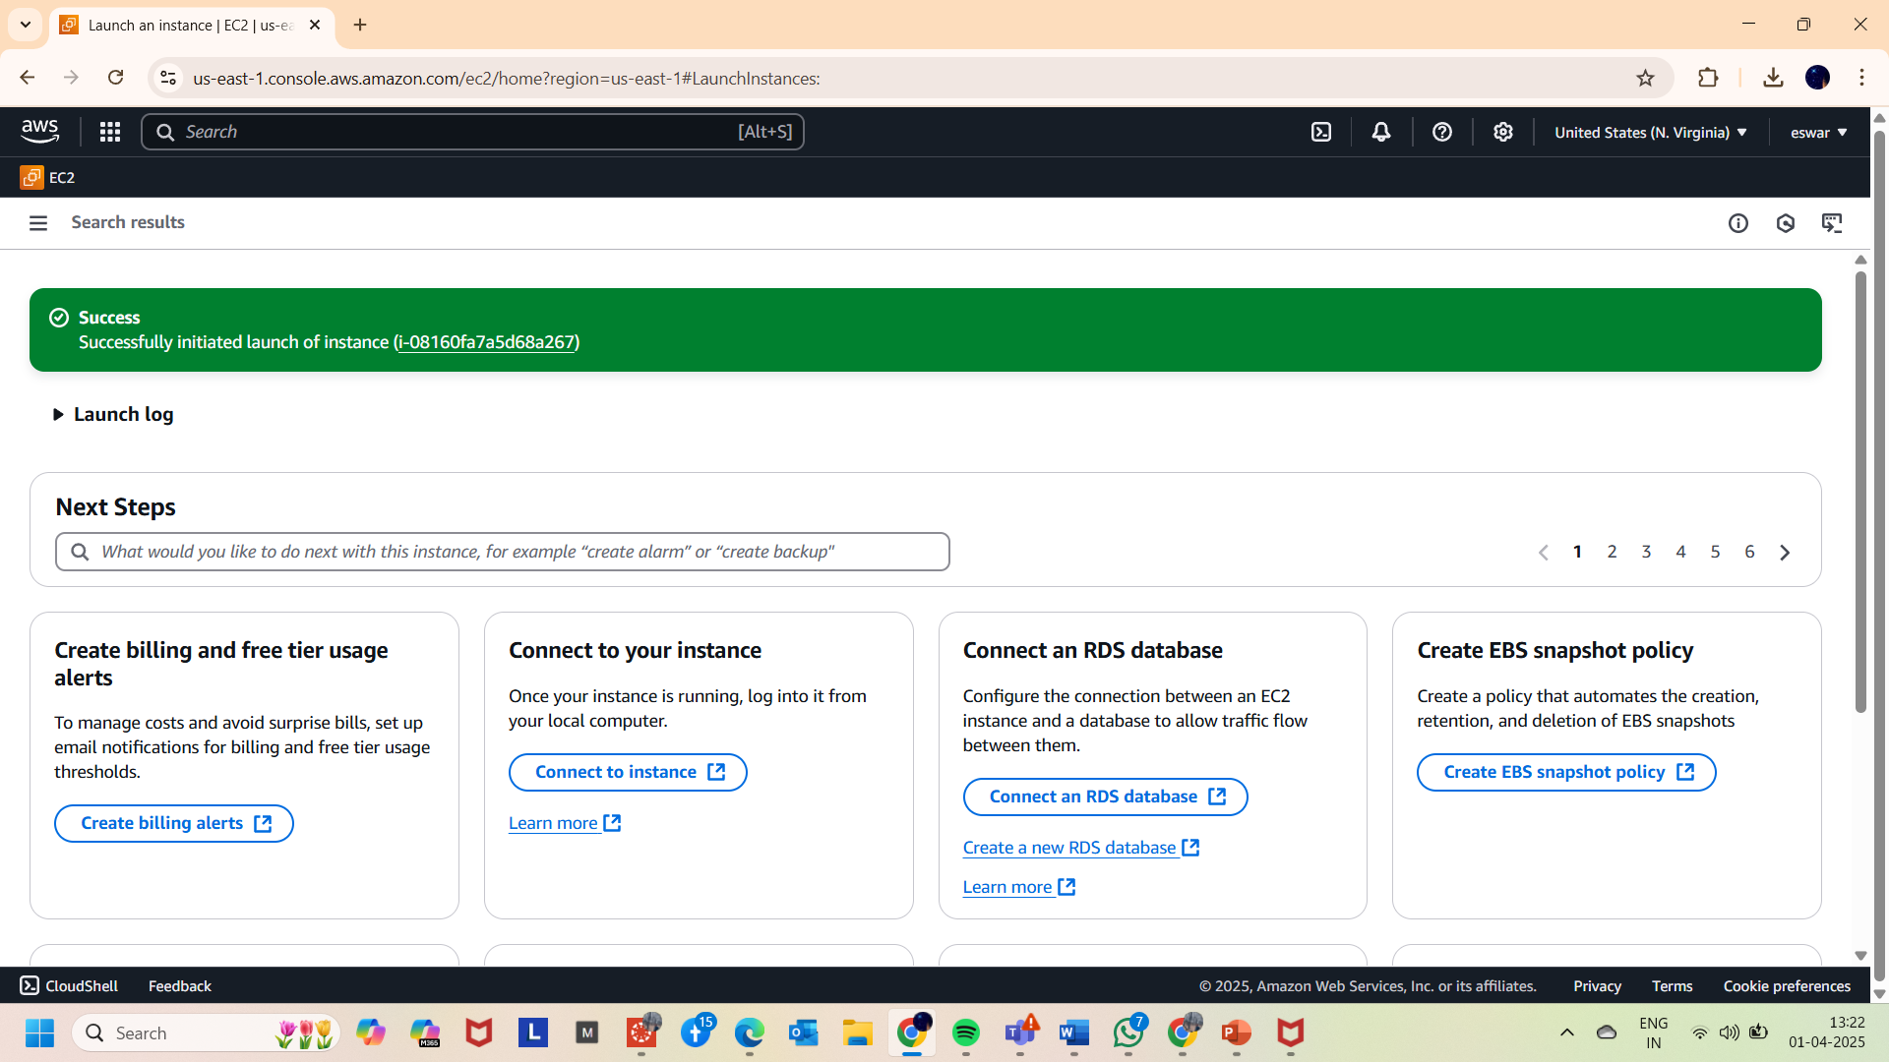

10. And in the instances checked on the instance “httpserver1” and copied the ip address

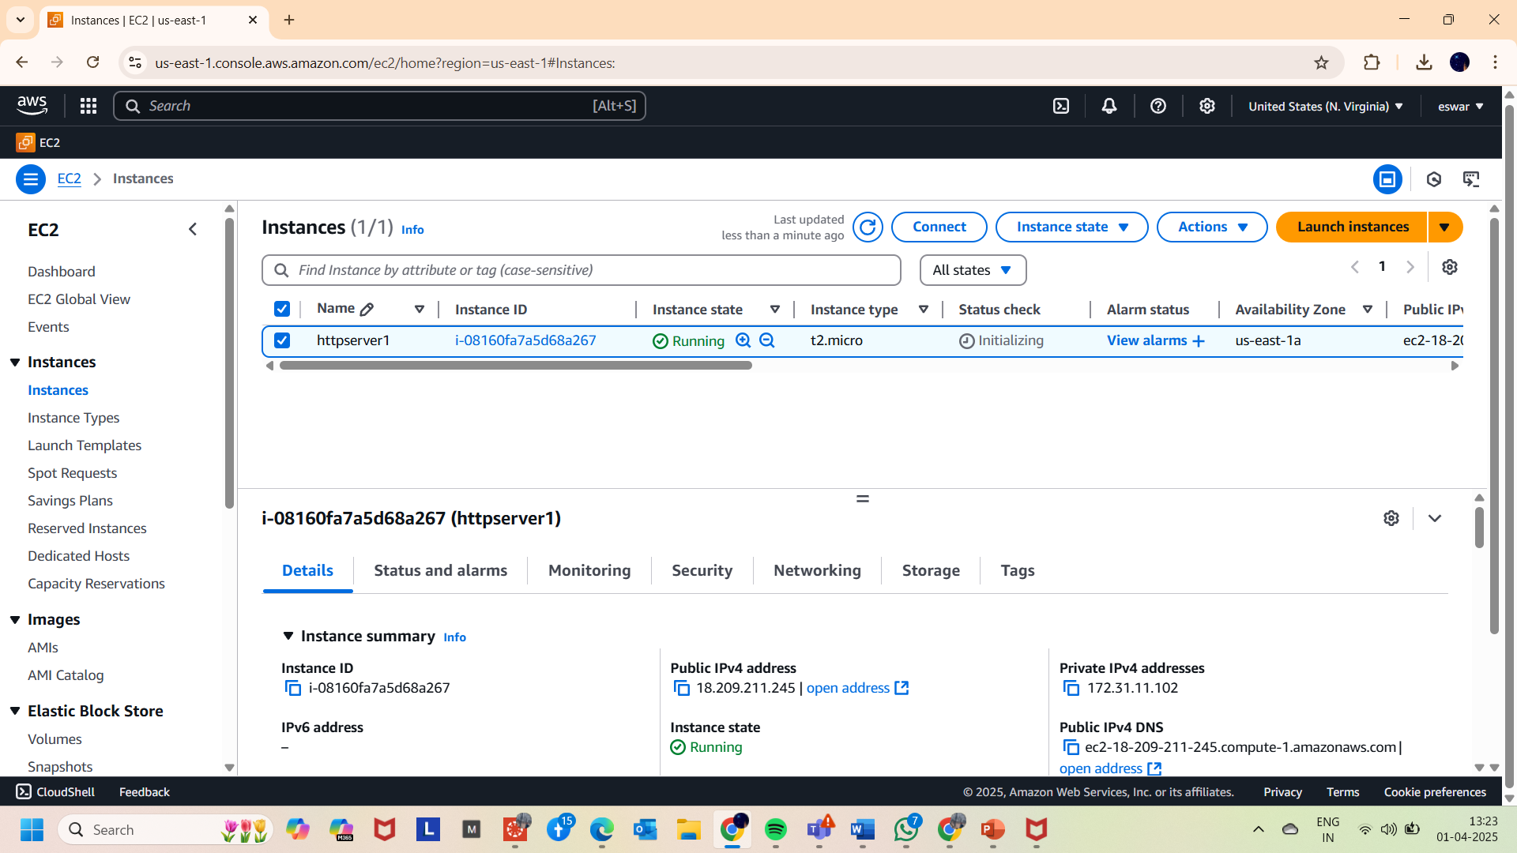

11. successfully the Ip address browsed and the required web page has been viewed as seen below

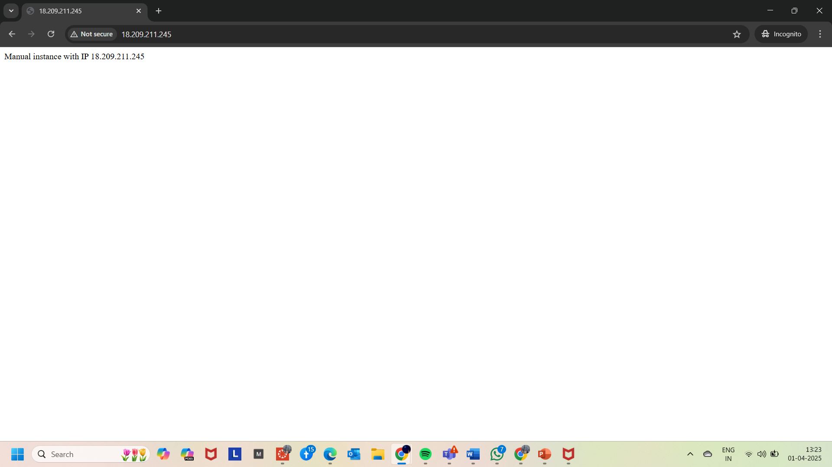

**PART 2: Launching an 2nd instance**

1. Created another instance with key value as **httpserver2** this will help to differentiate from previous instance

2. httpserver2 is deployed in **us-east-1b zone**

3.And the accessed the Ip address of **2nd instance** and **successfully** retrieved the page shown in 2nd image of this page.

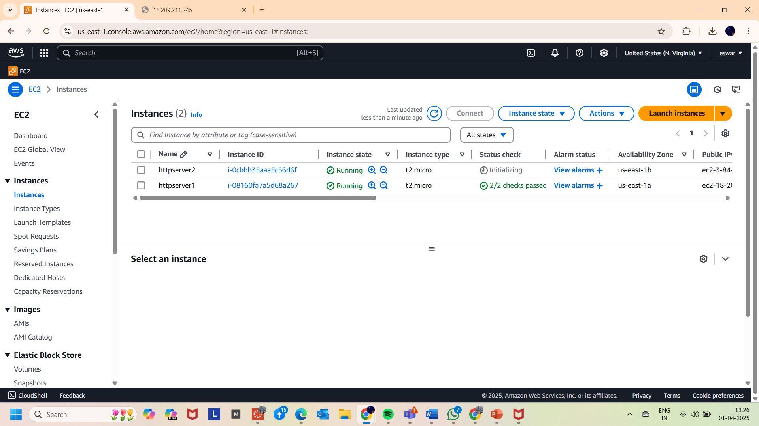

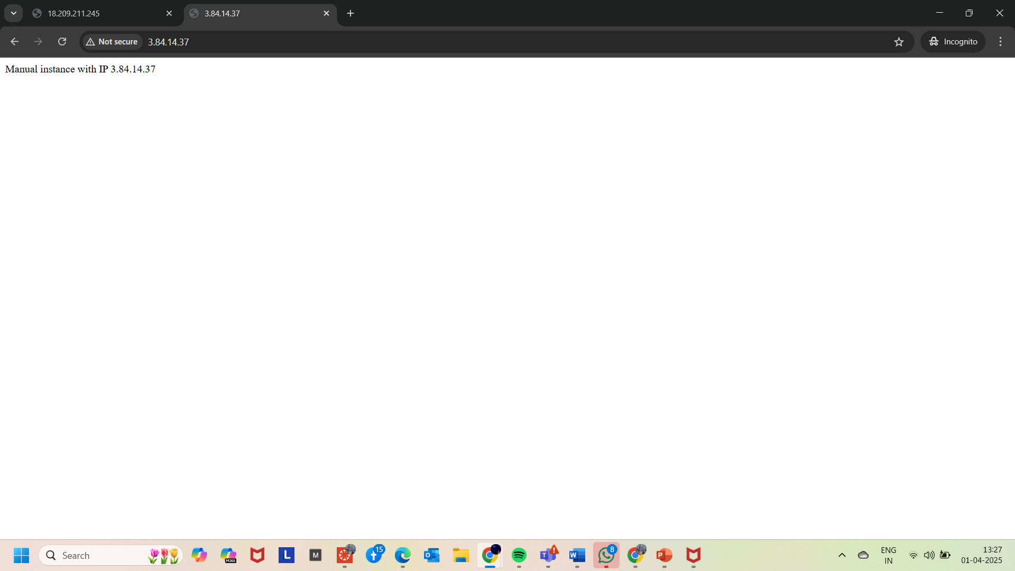

**Part 3: TARGET GROUP CREATION**

1.Opened the **TARGET GROUP** Feature under LOAD BALANCER section.

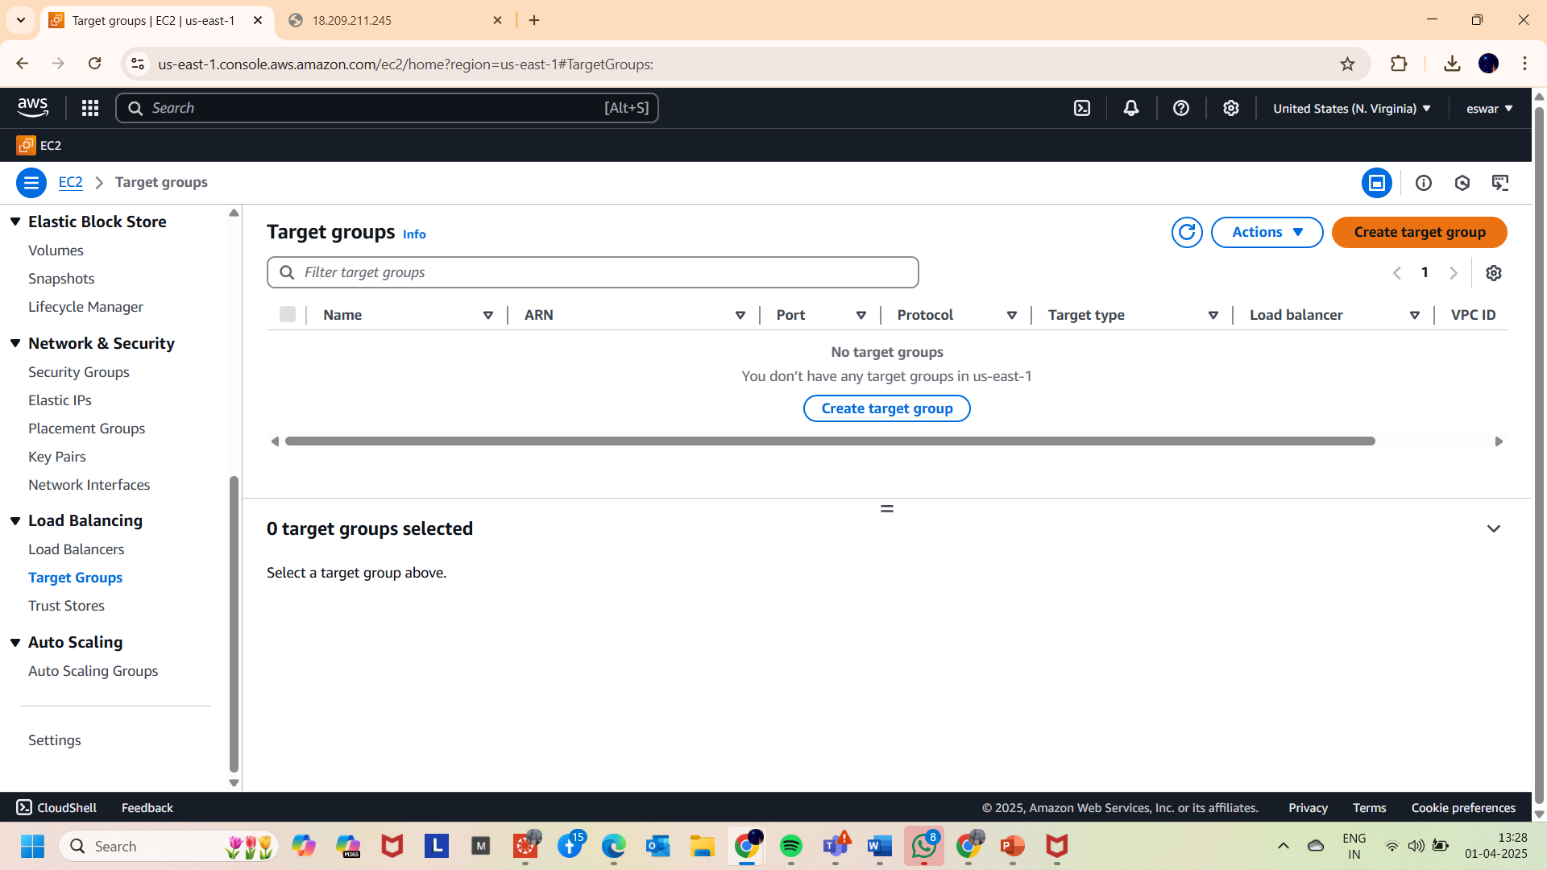

2.And after entering into the **CREATE TARGET GROUP** button on the left top corner.

3. selected **Instances** as Target type.

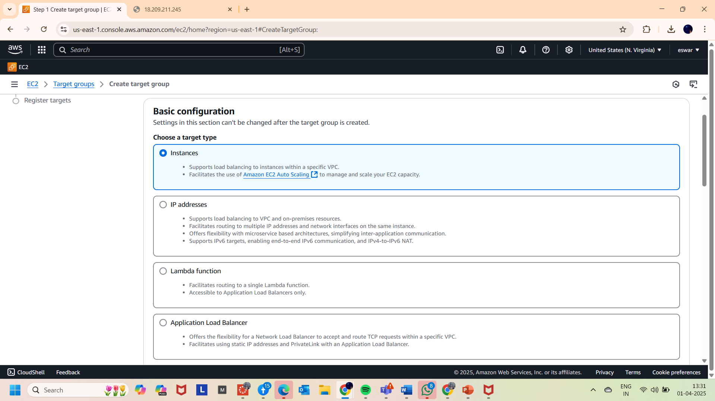

4. Given **web-tg** has Target Group name

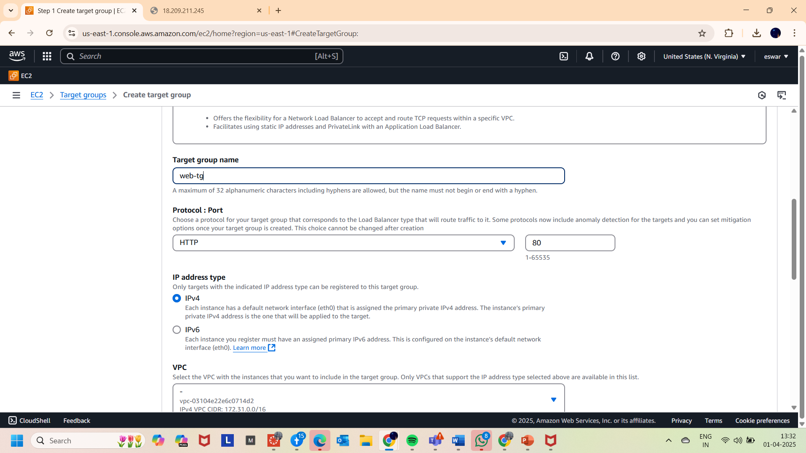

5. In the Health checks card added the “/health.html” text in the Health check path field and also updated the healthy threshold valkue to “2” from “5”.

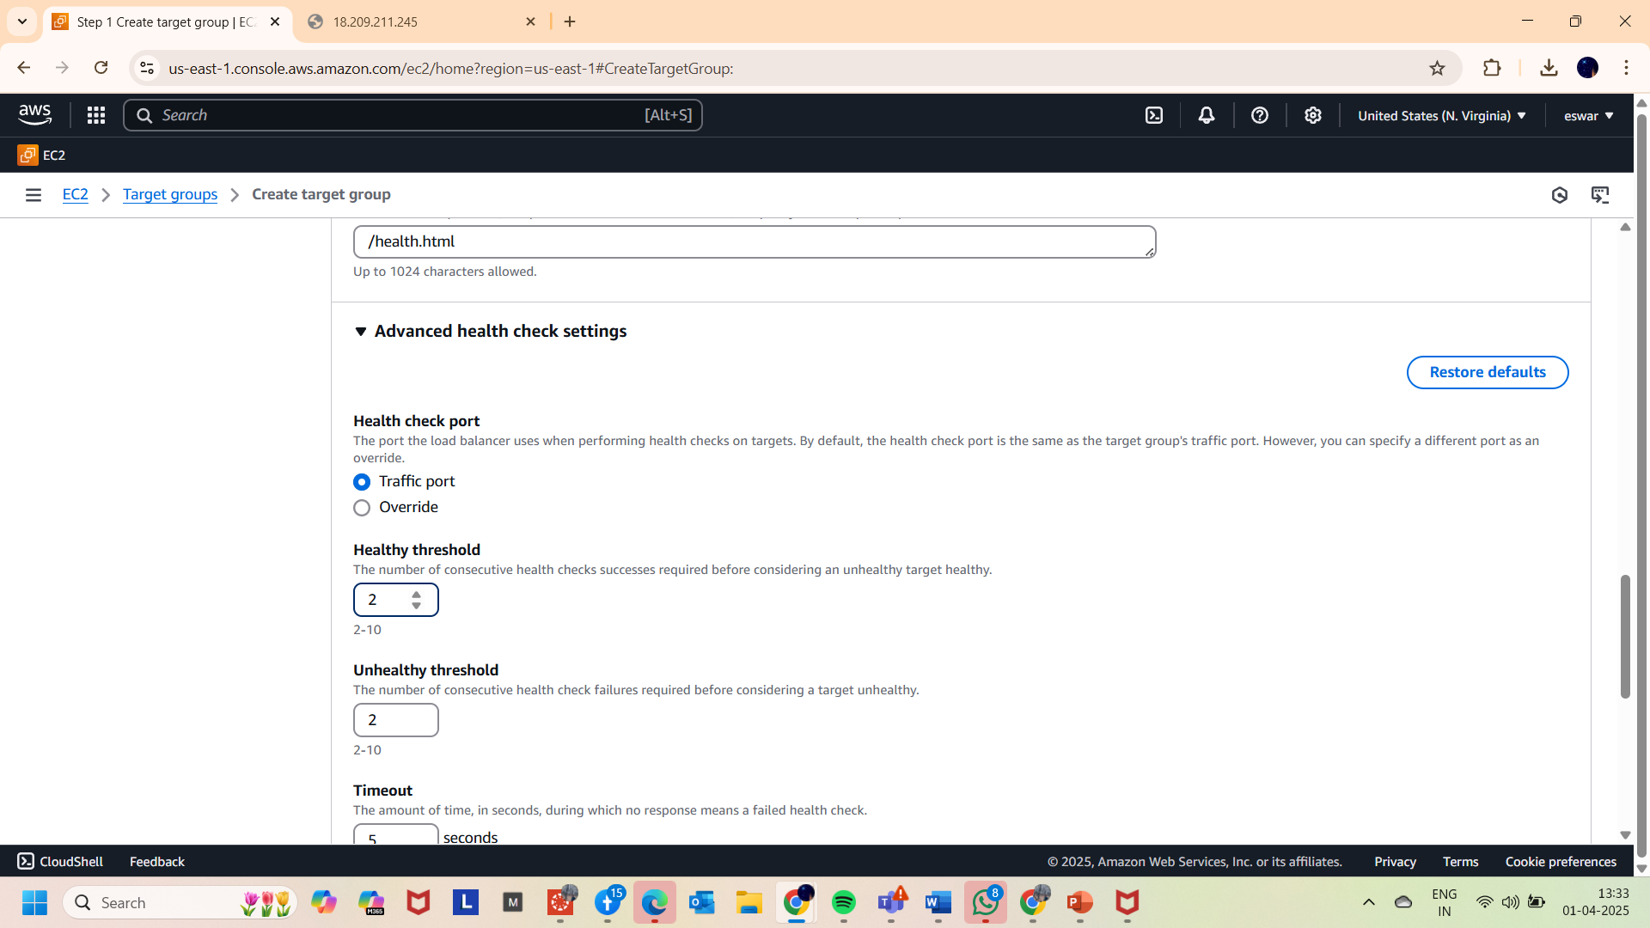

6.And NEXT, Included the two instance as pending below (as shown in below images)

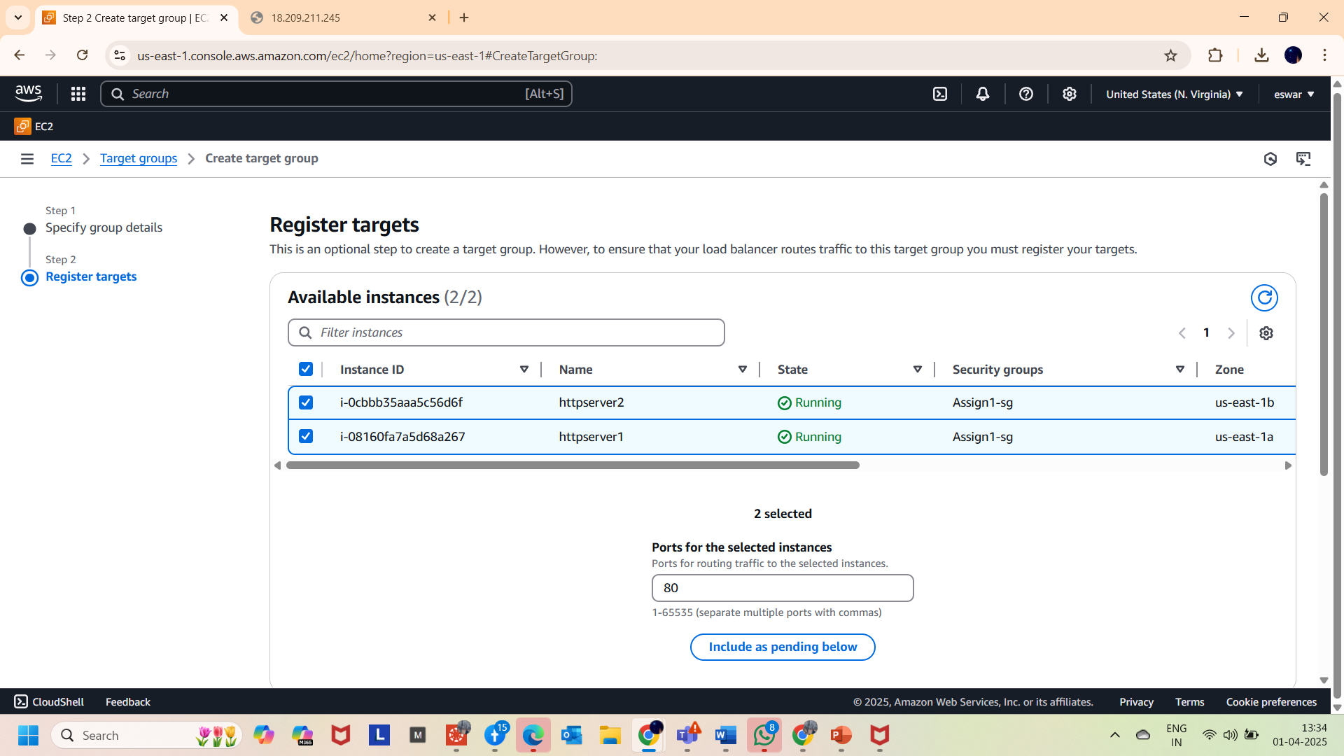

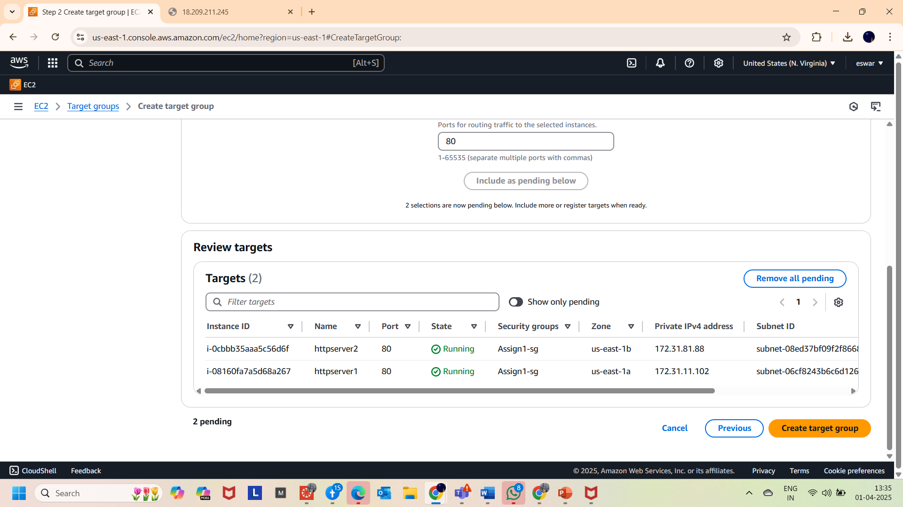

7.And successfully created the **TARGET GROUP** as shown below

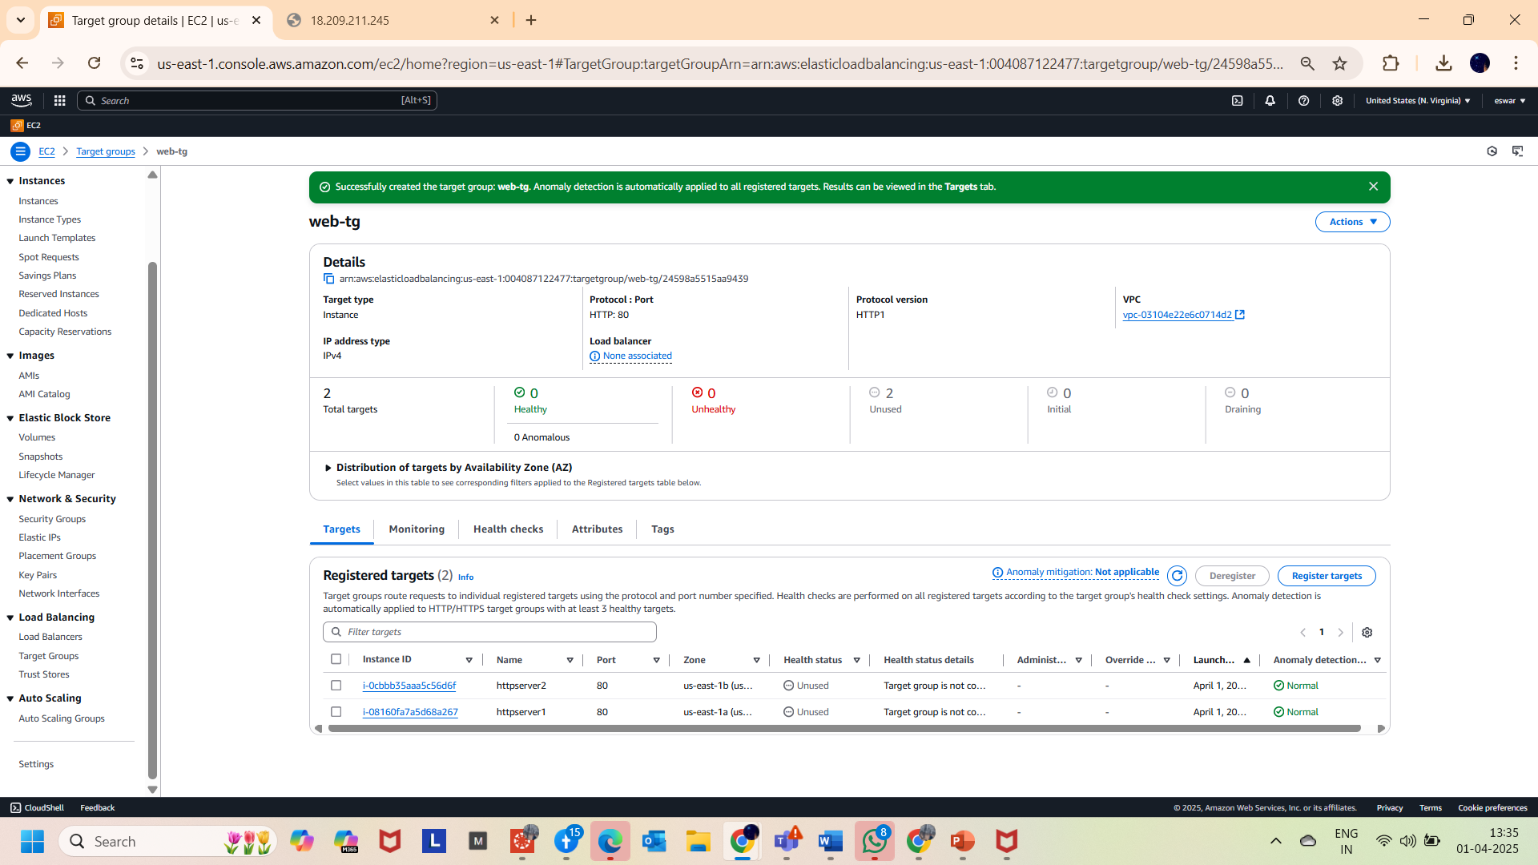

**PART 4: Creating an APPLICATION LOAD BALANCER**

1.Landed on the page of load balancer. And clicked on the “create load balancer “button.

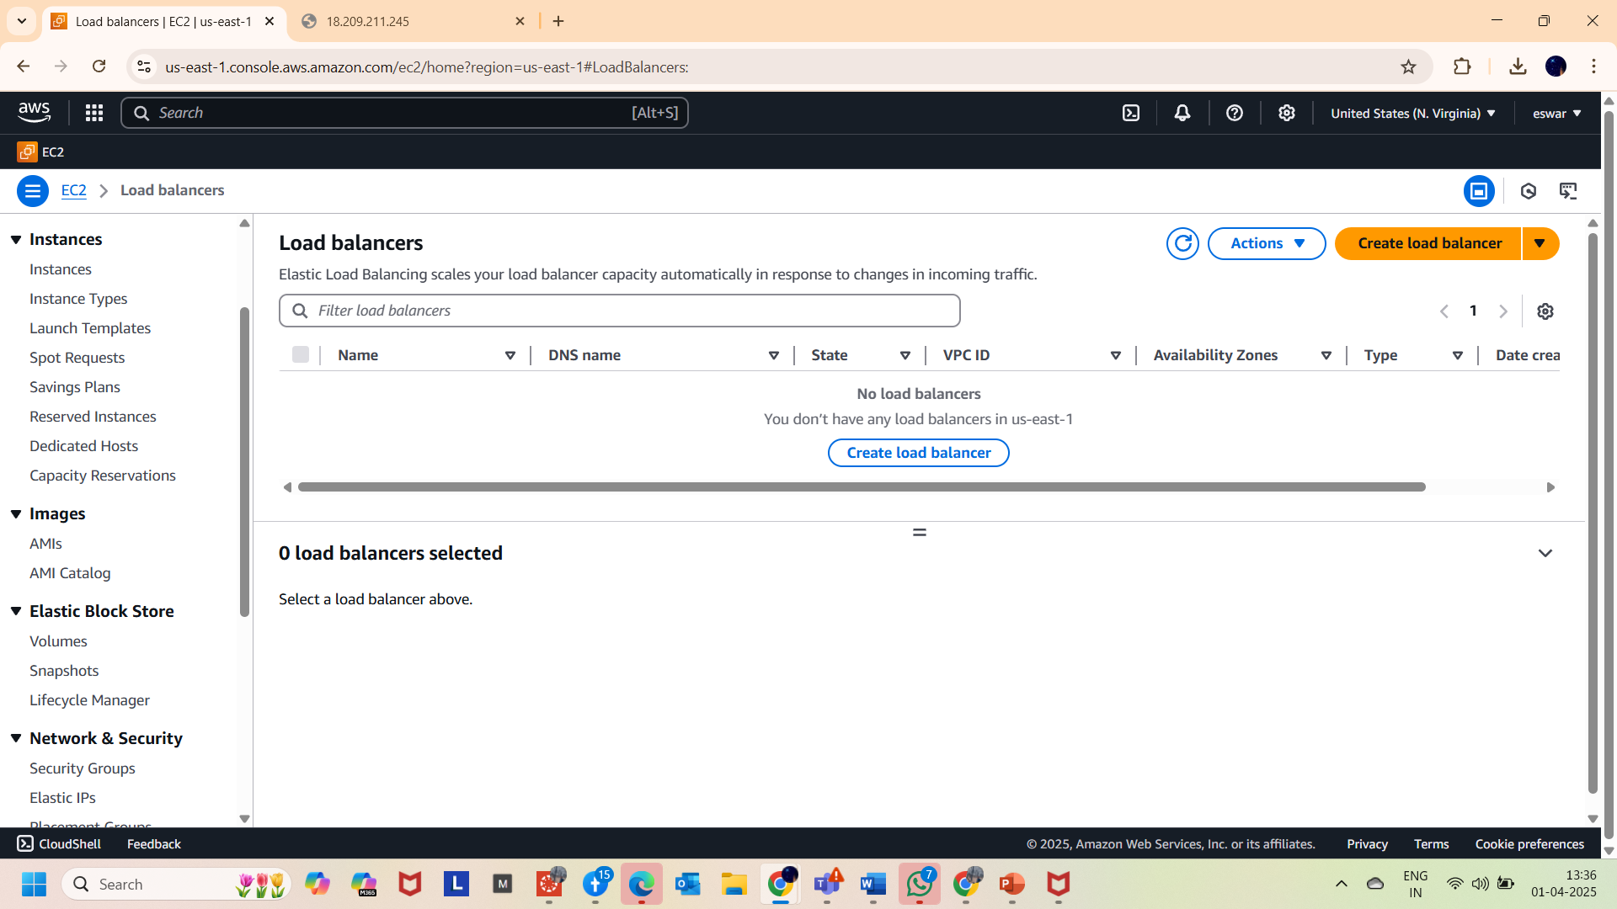

2. Selected the **Application Load Balancer** as Load balancer type.

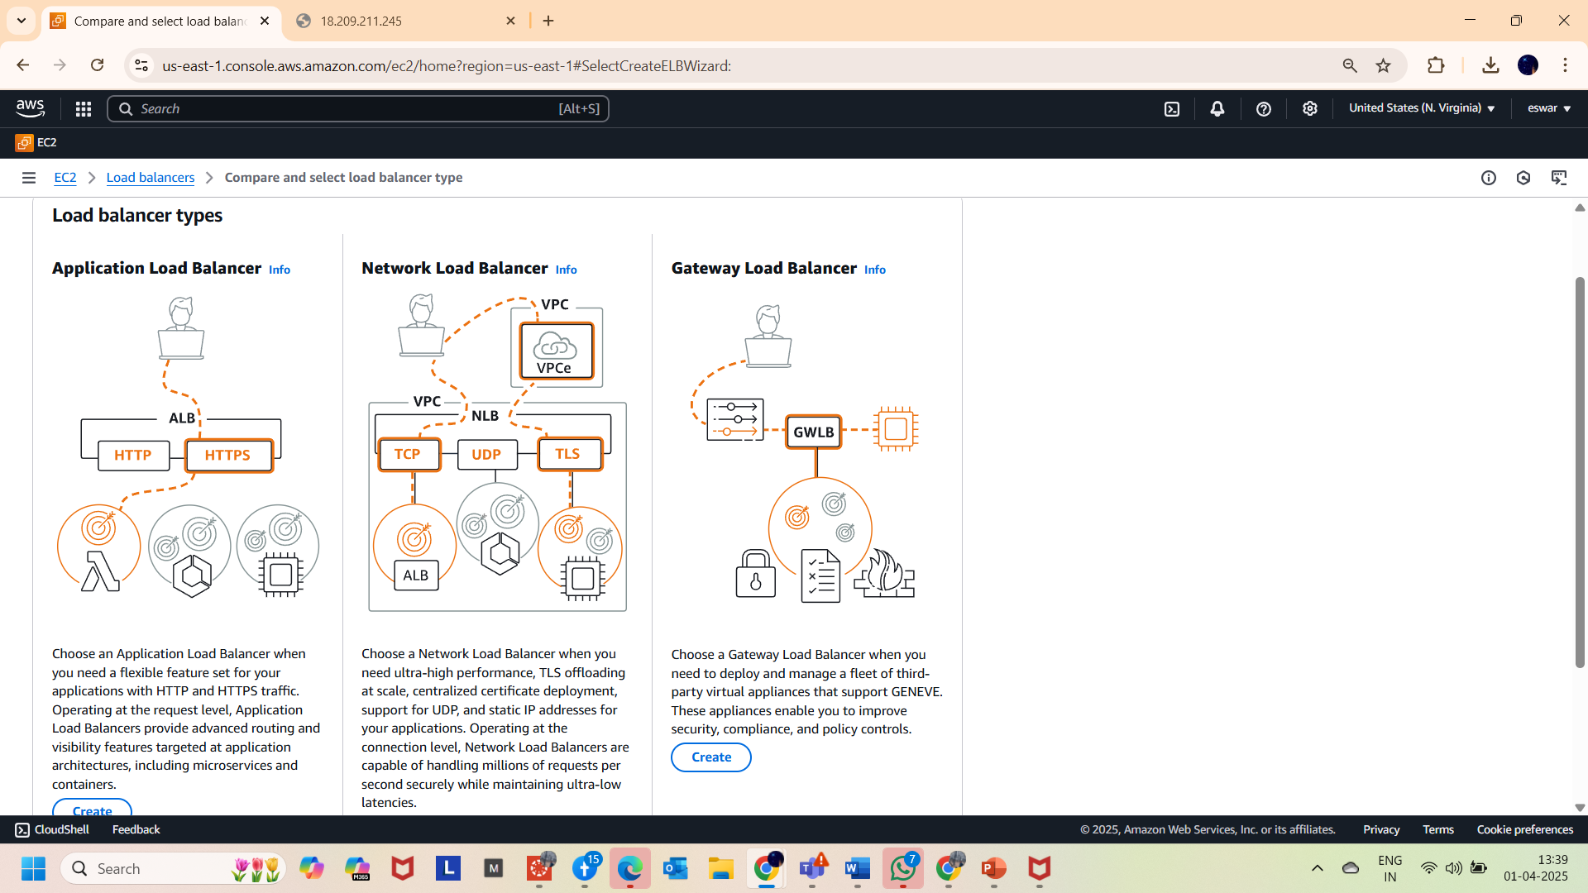

3. Given **web-lb** as Load Balancer name

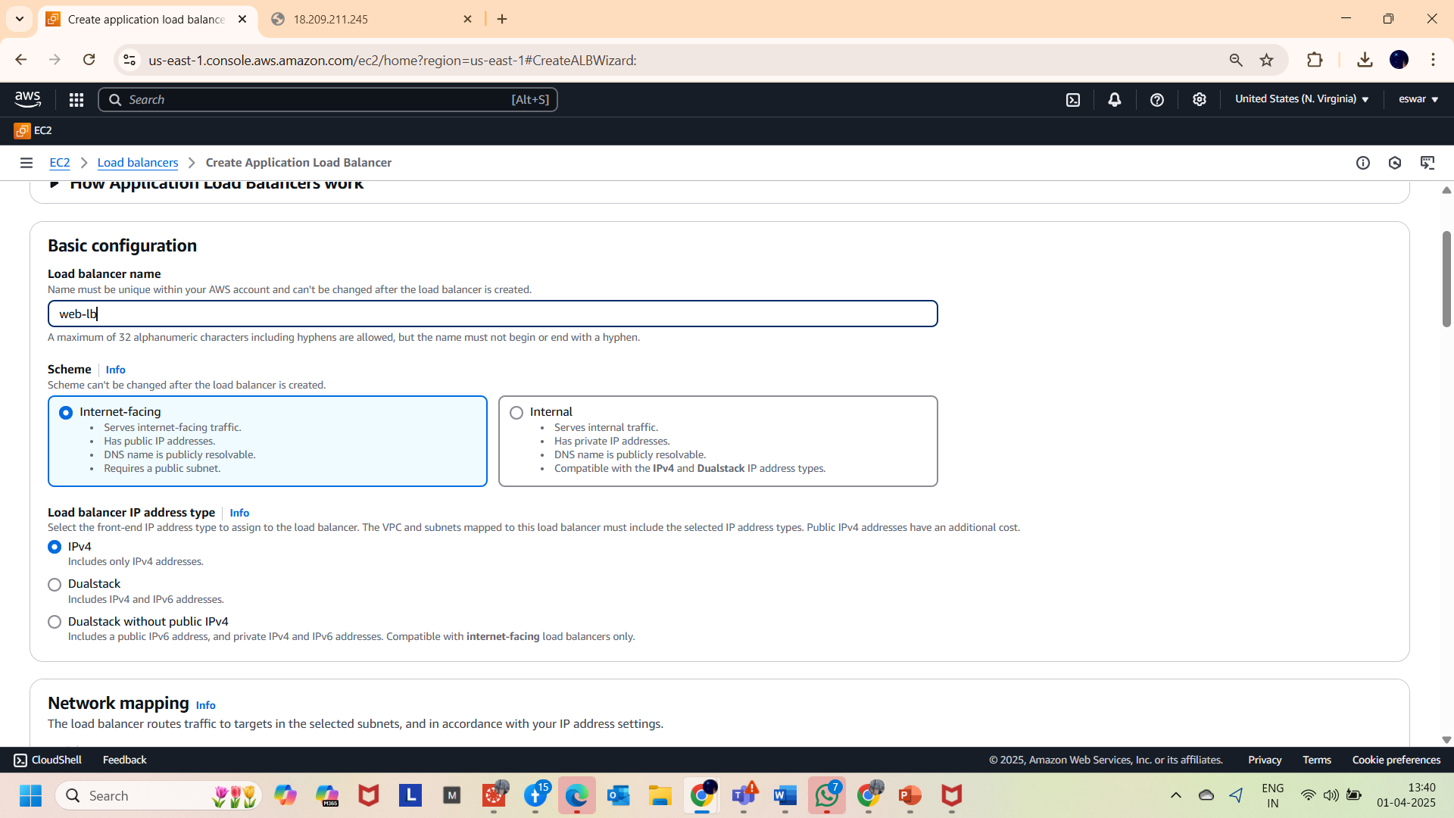

4. And selected all the zones and added “**assign-1 sg**” as security group

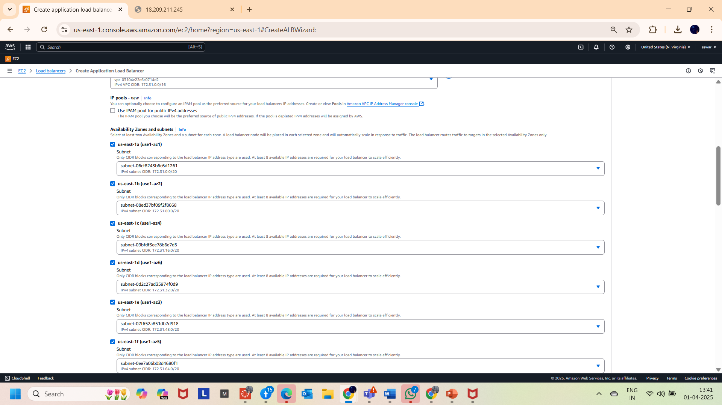

5.Selected **web-tg** from the dropdown in Listeners and routing.

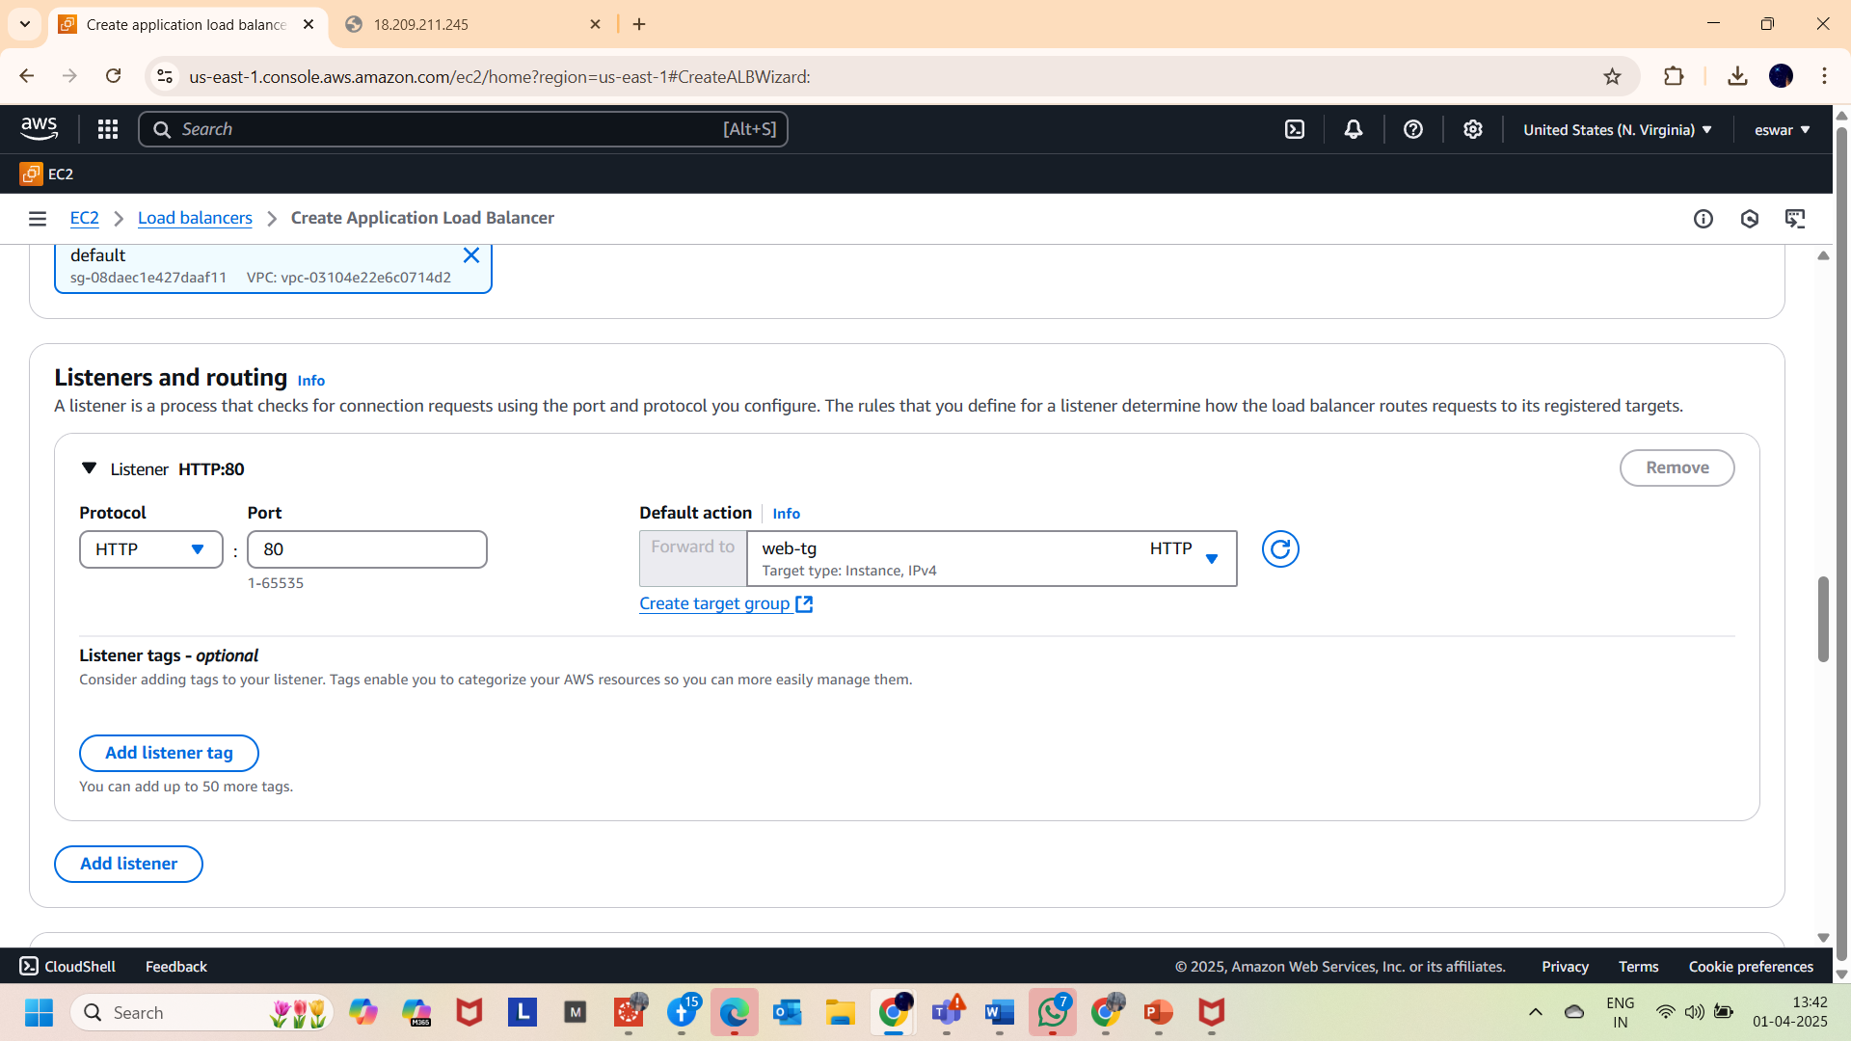

6. created a Load balancer as shown below.

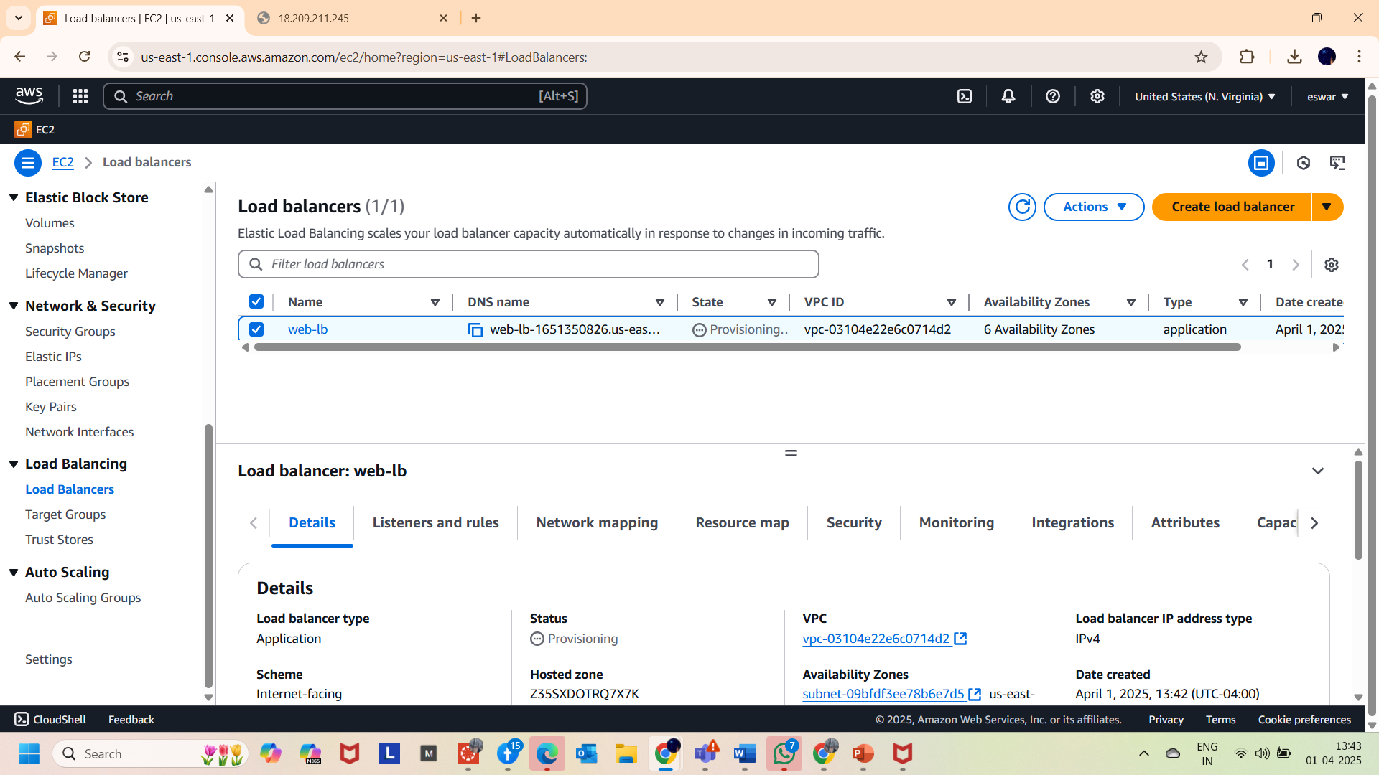

7. And Copied the DNS name of Load balancer and browsed in internet   
(http:// web-lb-1651350826.us-east-1.elb.amazonaws.com) and seen the results that..the IP address is changing when refreshing ..(captured the screenshots updated below)

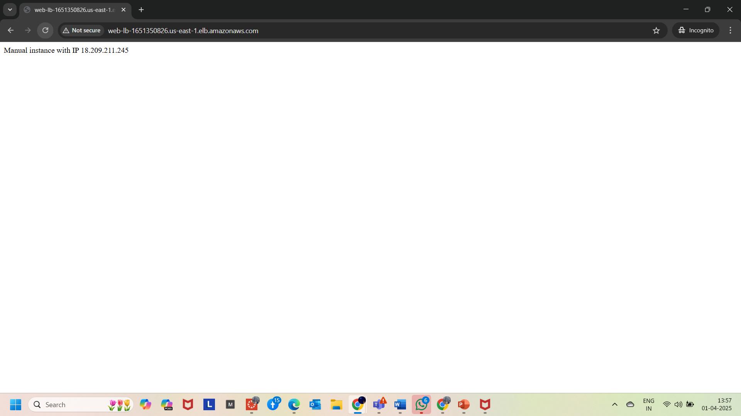

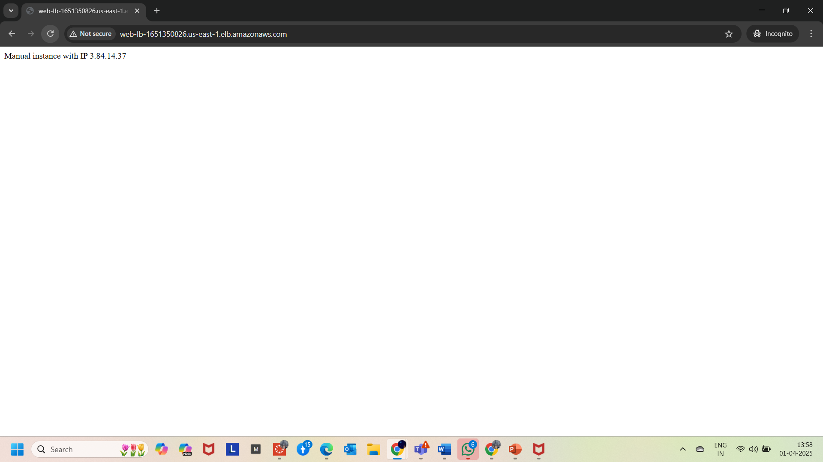

**Part5: SSH to an instance**  
  
1.SSH into the instance (httpserver 1) having private ip 172.31.11. 102.. (shown in 2nd image of this page)

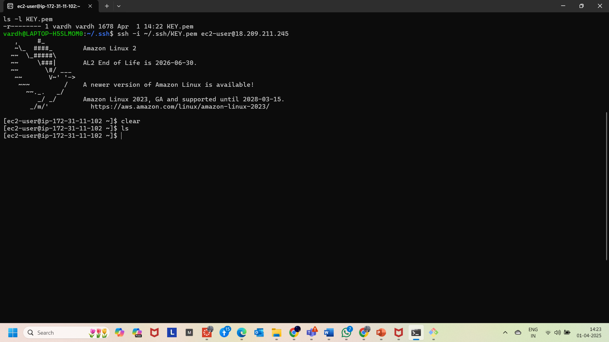

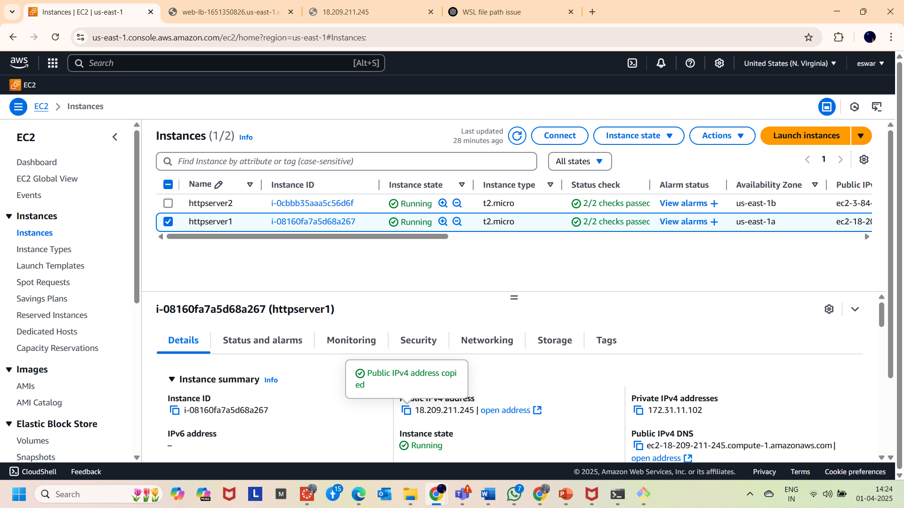

2. And performed some Linux commands as seen below.

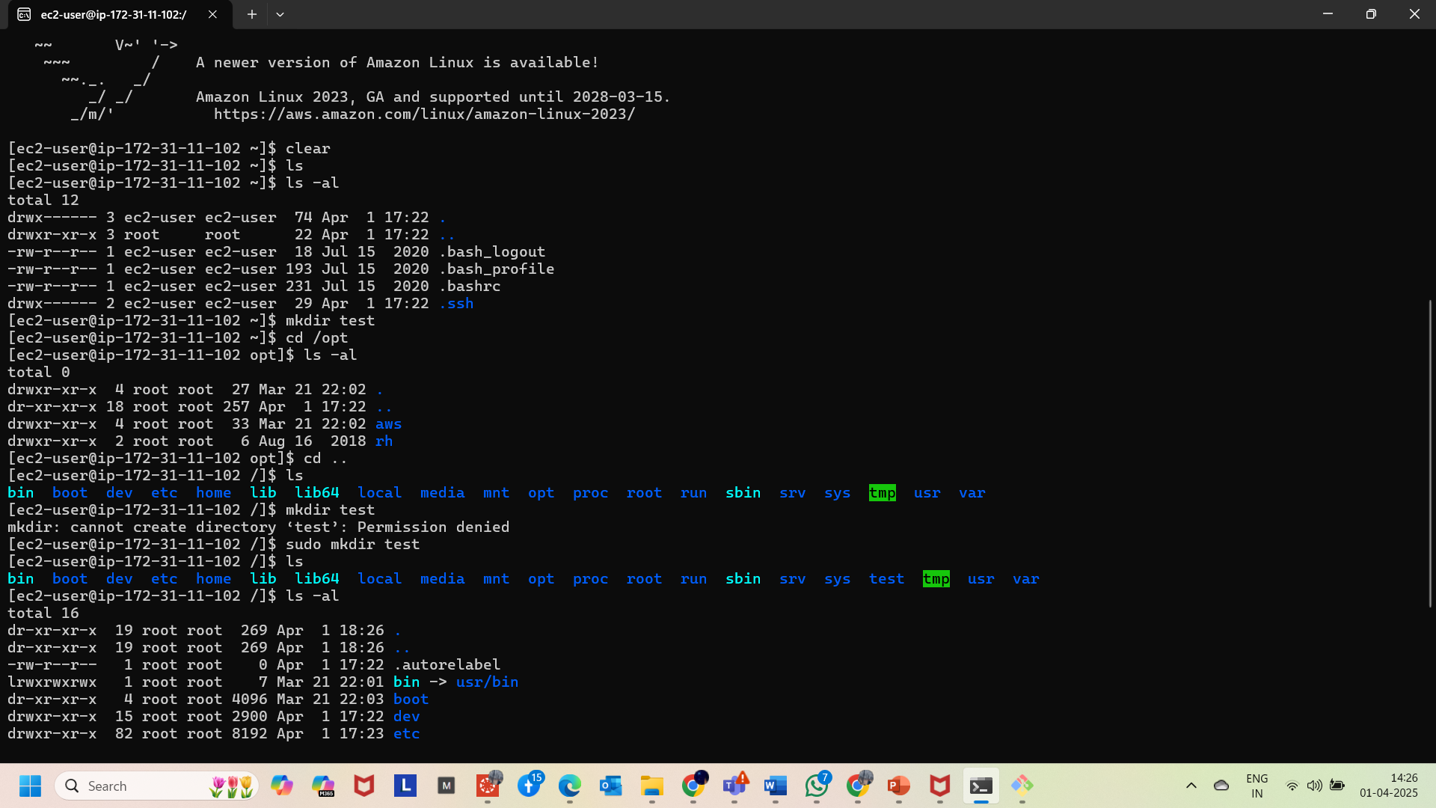

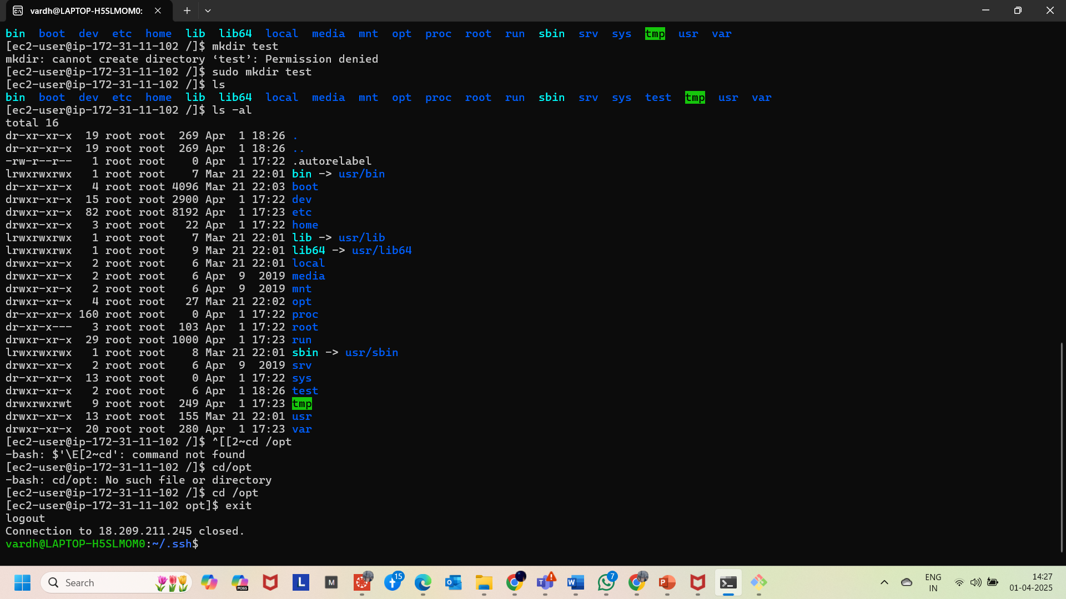

3.And also seen the alternate option of SSH. From **AWS console** and practised the same commands..and also observed the **mkdir** test is failed ..(due to already created the directory in local connect ssh)

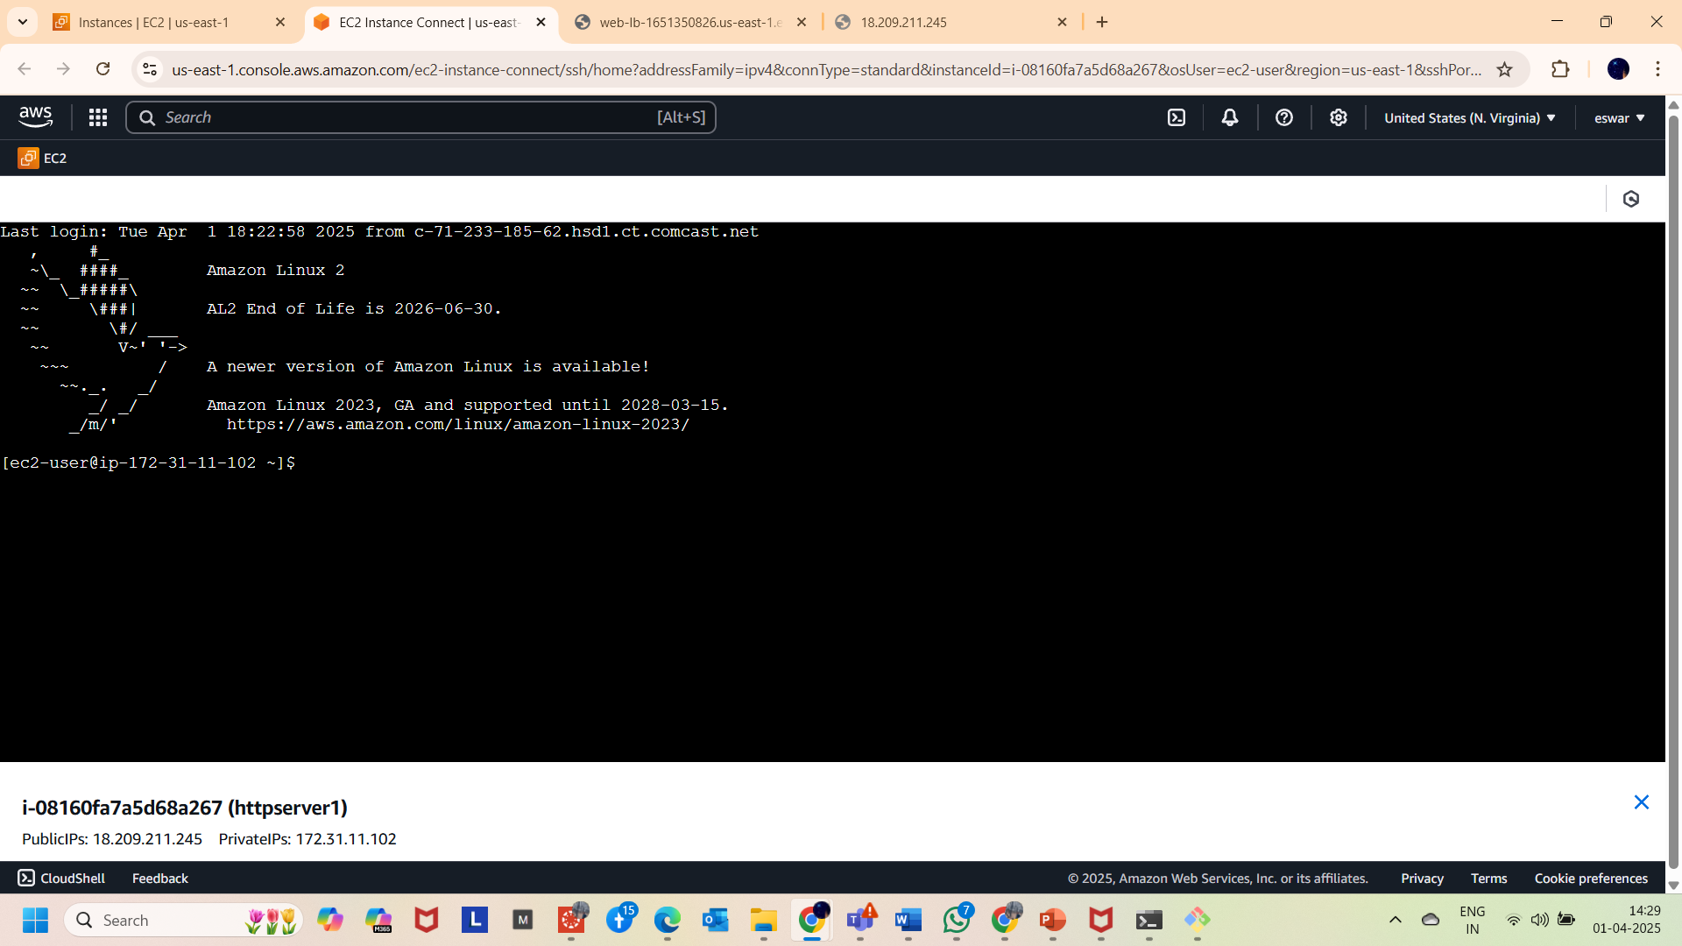

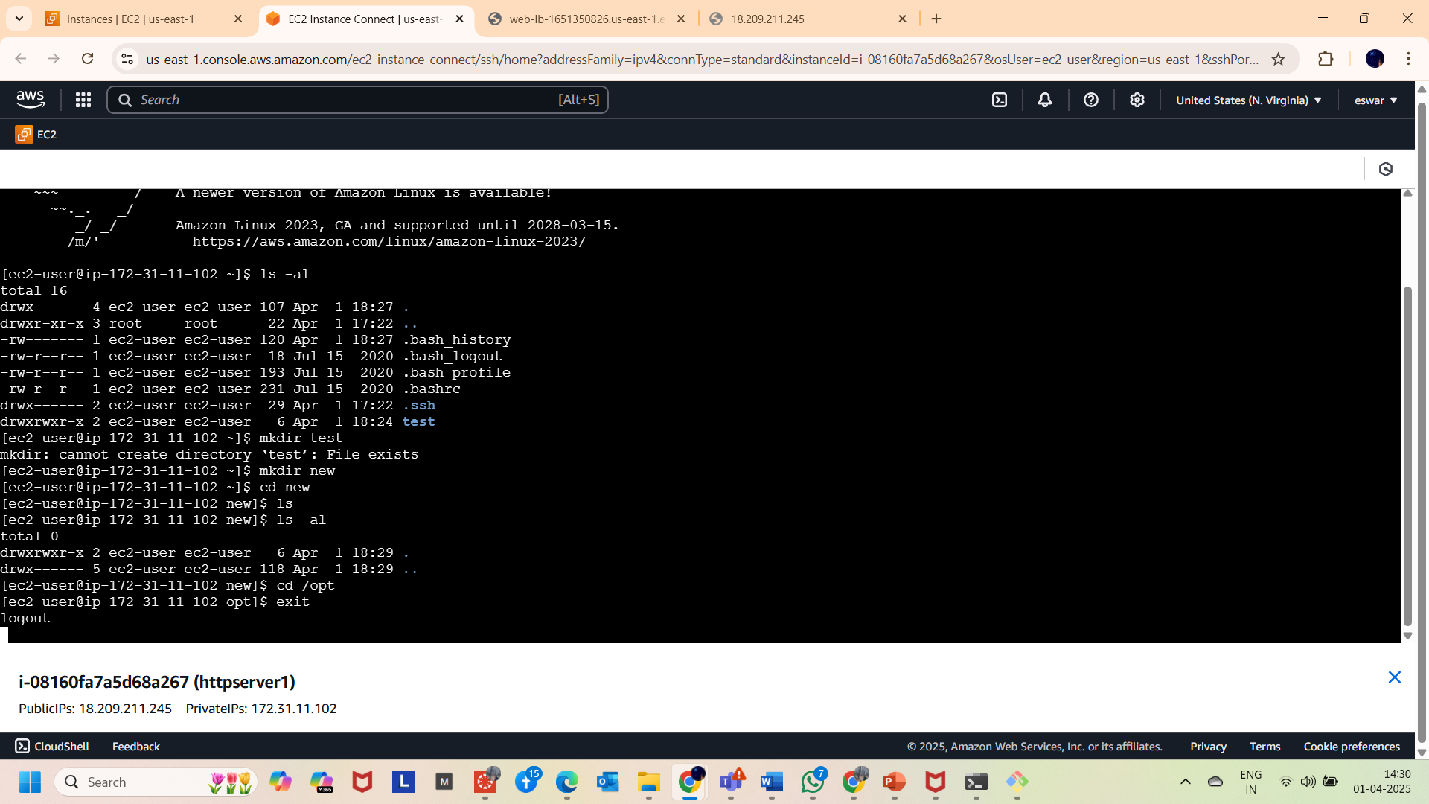

**PART 6: DELETING THE INSTANCES**

1. Terminated all the instances from AWS EC2 console as shown below.

